Ideation Phase
Brainstorm & Idea Prioritization Template

Date | 15 March 2025
Team ID | SWTID1744544274
Project Name | Book-Store
Maximum Marks | 4 Marks

Ideation Phase – Book Store Project
Prepared by: Fanish Kumar Diwan
Date: 15 March 2025

Brainstorm & Idea Prioritization:
The ideation phase is a crucial step in the development of our Book Store project, where I focus on generating and organizing ideas to enhance both functionality and user experience. Starting from the core MERN stack implementation I have explored and brainstormed a wide range of features, technologies, and integrations. This process helps us visualize the project roadmap, prioritize development tasks, and identify both quick wins and long-term enhancements. The ideas have been categorized into core features, additional enhancements, tech stack improvements, and advanced/future possibilities. To further refine the direction of the project, we use an Idea Prioritization Matrix that evaluates each idea based on its impact and the effort required to implement it.
Step-1: Select the Problem Statement
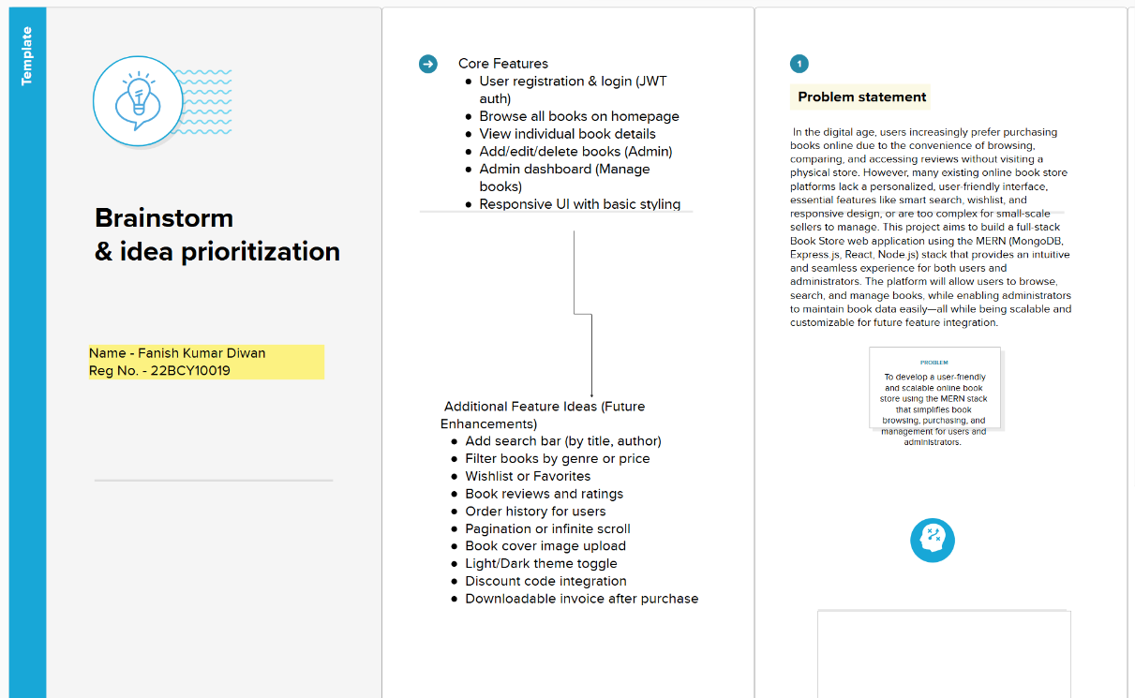

Step-2: Brainstorm, Idea Listing and Grouping
n this phase, the goal is to generate as many ideas as possible for enhancing the Book Store application. These ideas will focus on different aspects of the project, including features, technologies, and user experience improvements. After generating the ideas, we will categorize and group them based on their function or relation to each other. This grouping will help in identifying which ideas should be prioritized based on their impact and the effort required for their implementation.

1. Core Features
- User Registration and Authentication
Allow users to sign up and log in using a secure authentication system (JWT).
- Book Browsing
Display a list of books on the homepage with features like sorting and filtering by genre, author, and price.
- Book Details Page
Provide users with detailed information about each book, including a description, author information, and pricing.
- Admin Dashboard
Enable an admin to manage the books, add new books, delete, or edit existing books in the store.
- Search Functionality
Allow users to search for books by title, author, or genre.

2. User Experience Enhancements
- Wishlist/Favorites
Allow users to save their favorite books to a wishlist for future purchases.
- Book Reviews and Ratings
Enable users to rate books and leave reviews, helping others make informed decisions.
- Order History
Users can view past orders and keep track of purchases.
- Responsive Design
Ensure the website works seamlessly on all devices, from desktops to smartphones.

3. Tech Stack & Integrations
- React for Frontend
Utilize React for a dynamic and fast user interface, paired with TailwindCSS for styling.
- Node.js and Express for Backend
Use Node.js and Express to build the backend API to handle book data, user management, and authentication.
- MongoDB
Store book data, user profiles, and order histories in MongoDB to handle large volumes of data efficiently.
- Cloudinary or Firebase for Image Hosting
Use Cloudinary or Firebase for storing and serving book cover images.
- Stripe/Razorpay for Payment Integration
Integrate a payment gateway to handle online payments securely.

4. Future Features (Advanced Ideas)
- AI-Powered Book Recommendations
Use machine learning algorithms to suggest books to users based on their browsing and purchase history.
- Chatbot for Customer Support
Integrate a chatbot to assist users with their queries related to books, orders, and other services.
- Audiobook Preview
Provide a sample audio clip or preview for audiobooks, giving users a taste before purchasing.
- QR Code Scanner
Implement a feature that allows users to scan QR codes on books for instant access to purchase information.

5. Grouping and Categorizing Ideas
After brainstorming the ideas, it’s important to group them based on their functionality and target audience. This allows us to focus on developing specific features that can make an impact right away.

Functional Groupings:
- User Management:
  - User registration and login
  - Wishlist/Favorites
  - Order History
- Book Management:
  - Book browsing and details page
  - Admin dashboard for book management
- Search & Discovery:
  - Search functionality (by title, author, genre)
  - AI-powered book recommendations
  - Book reviews and ratings

Tech/Development Groupings:
- Frontend:
  - React for dynamic UI
  - TailwindCSS for responsive design
- Backend:
  - Node.js and Express.js for API
  - MongoDB for data storage
- Integrations:
  - Authentication
  - Data Storage
By grouping and categorizing ideas, we have a clearer understanding of how to approach development and which features will complement each other.

Step-3: Idea Prioritization
. Idea Prioritization Matrix – Table View
This matrix categorizes the brainstormed features based on their impact and the effort required for implementation.
Category | Features
✅ Quick Wins (High Impact, Low Effort) | Search bar (title/author)  Pagination for book list  Book cover upload  Toast notifications for actions
🧗 Big Bets (High Impact, High Effort) | Wishlist/favorites system  Payment gateway (Stripe/Razorpay)  Book reviews and ratings  Order history & downloadable invoices  AI-powered recommendations
💤 Maybes (Low Impact, Low Effort) | Social media login  Book genre filtering  Discount/coupon code support
❌ Time Wasters (Low Impact, High Effort) | Audiobook streaming  Chatbot with NLP  QR code ISBN scanner  Complex animations for UI transitions

